|  |  |
| --- | --- |
| TEAM ID | NM2023TMID08660 |
| TEAM MEMBERS | SWETHA.K, PADMAPRIYA.D, MEENATCHI. T, DEEPA.M. |
| BRAND NAME | BAGGAGE BLISS |
| CATEGORY | BAGS |
| TARGET AUDIENCE | ALL(Hand bags , Trolley , School Bags) |
| EMAIL | baggageblissbb@gmail.com |
| RECORDED VIDEO LINK | <https://youtu.be/INCZWZyN2jM?si=-gkZA929i-bciFMN> |
| LOGO THEME | TYPHOGRAPHY INITIALS LOGO |

**STEP:1 Create an EMAIL account for your brand.**

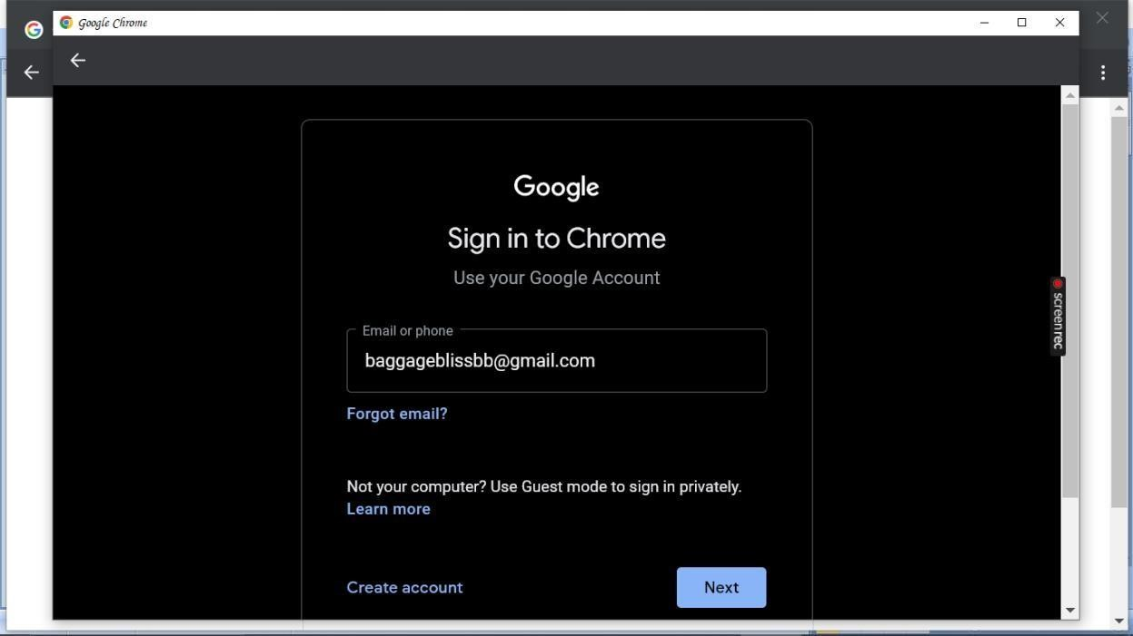

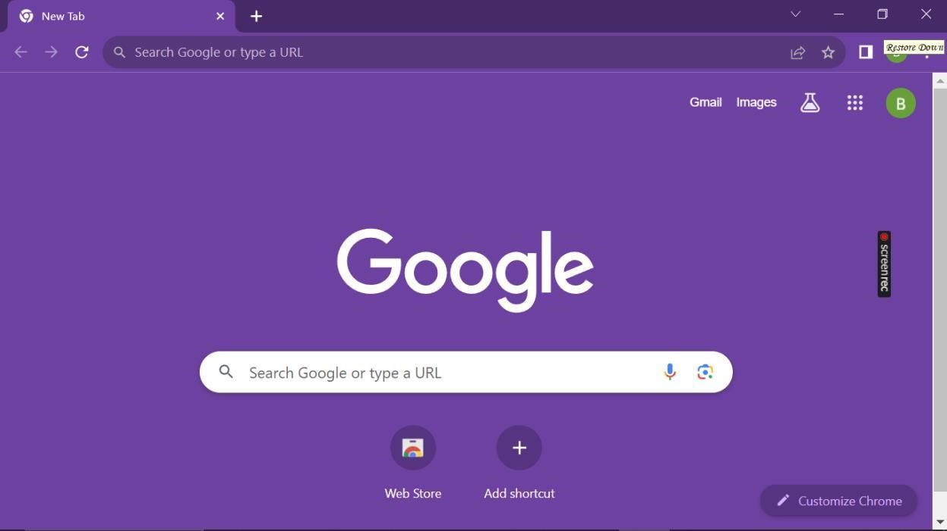

**STEP:2 Open a web browser and search canva’s website**.

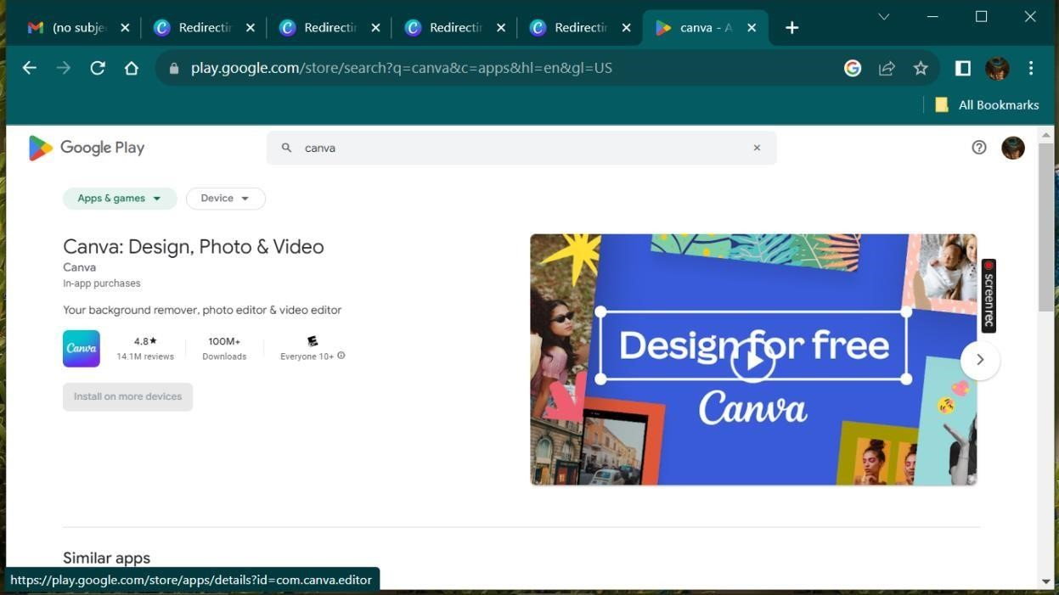

**STEP:3 If you already have a canva account, “LOG IN”. If not, you can sign up for a new account using email id, google or Facebook**.

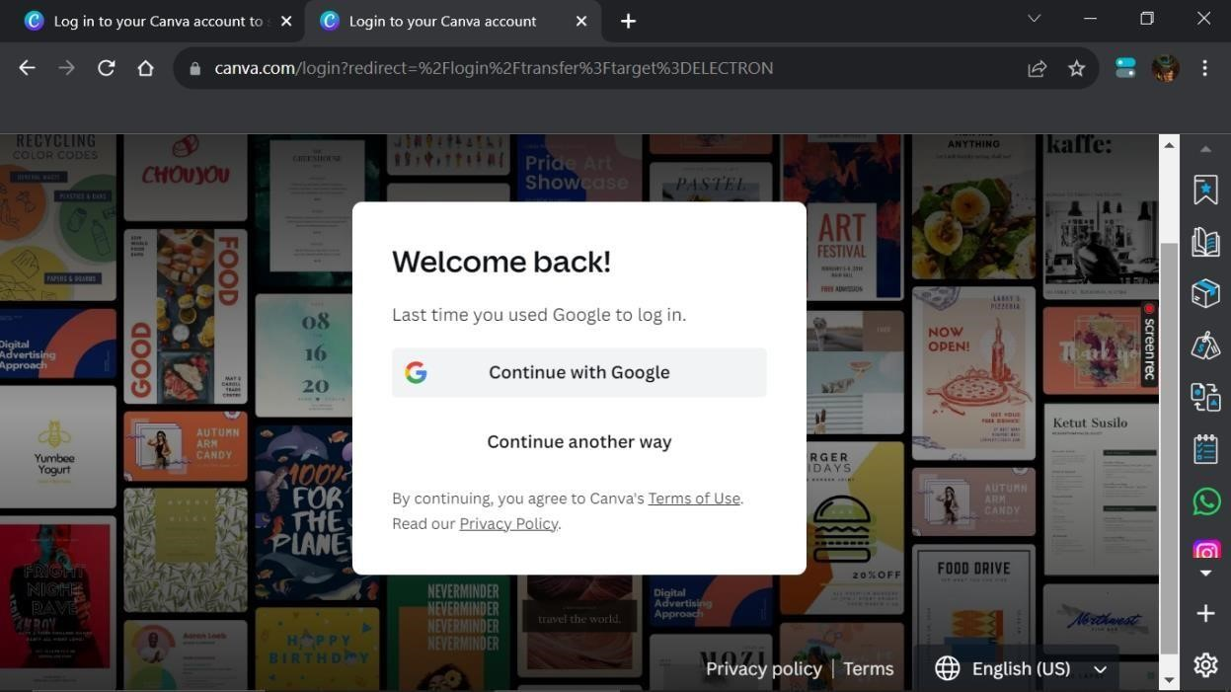

**STEP:4 After login open canva’s application and click on “Create a design” at the top right corner.**

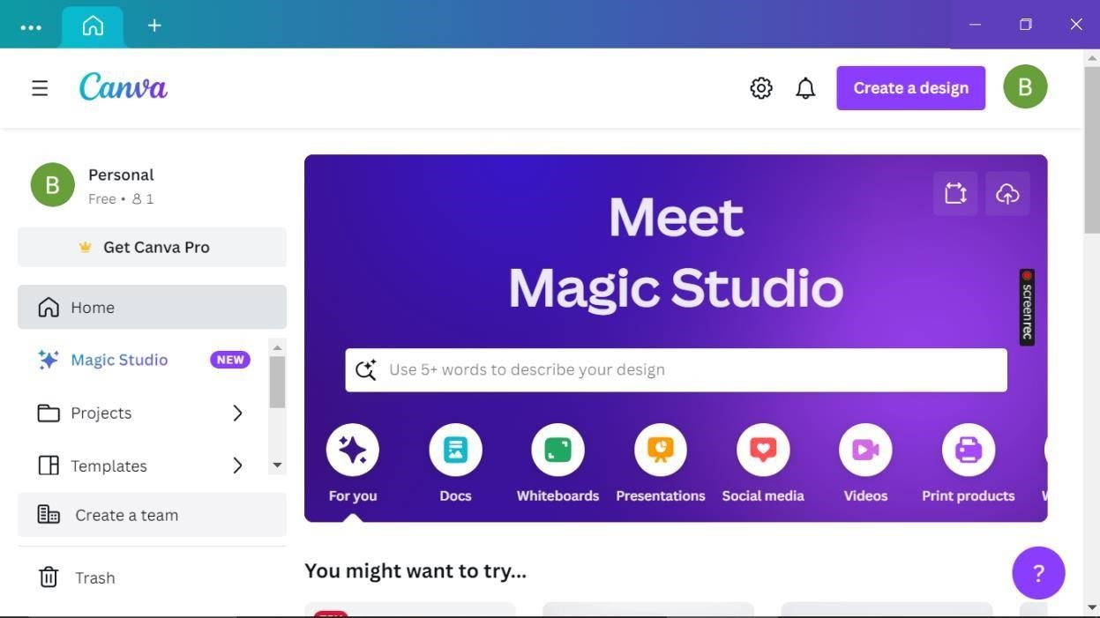

**STEP:5 In the search bar at the top of the page type “logo template”.**

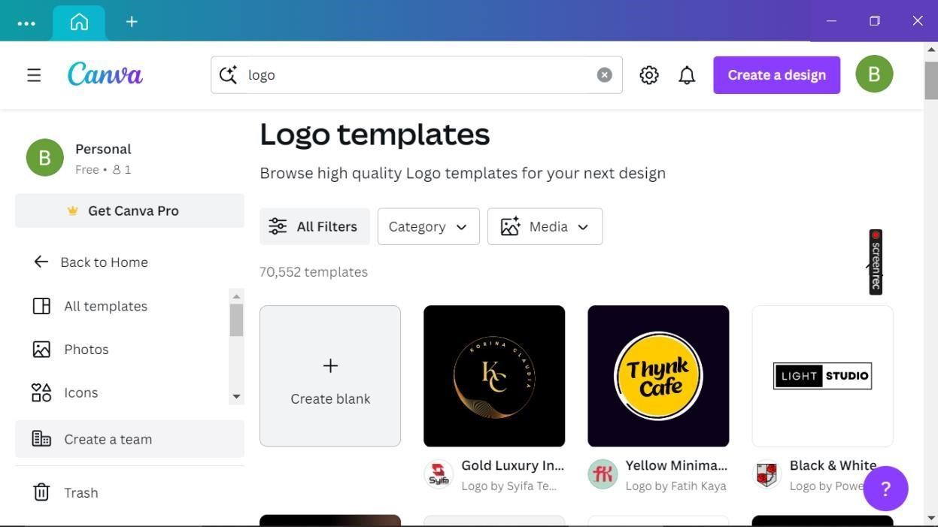

**STEP:6 Click on a template that you want to use. It will open in canva design editor, where you can customize it with your own text, image and elements**.

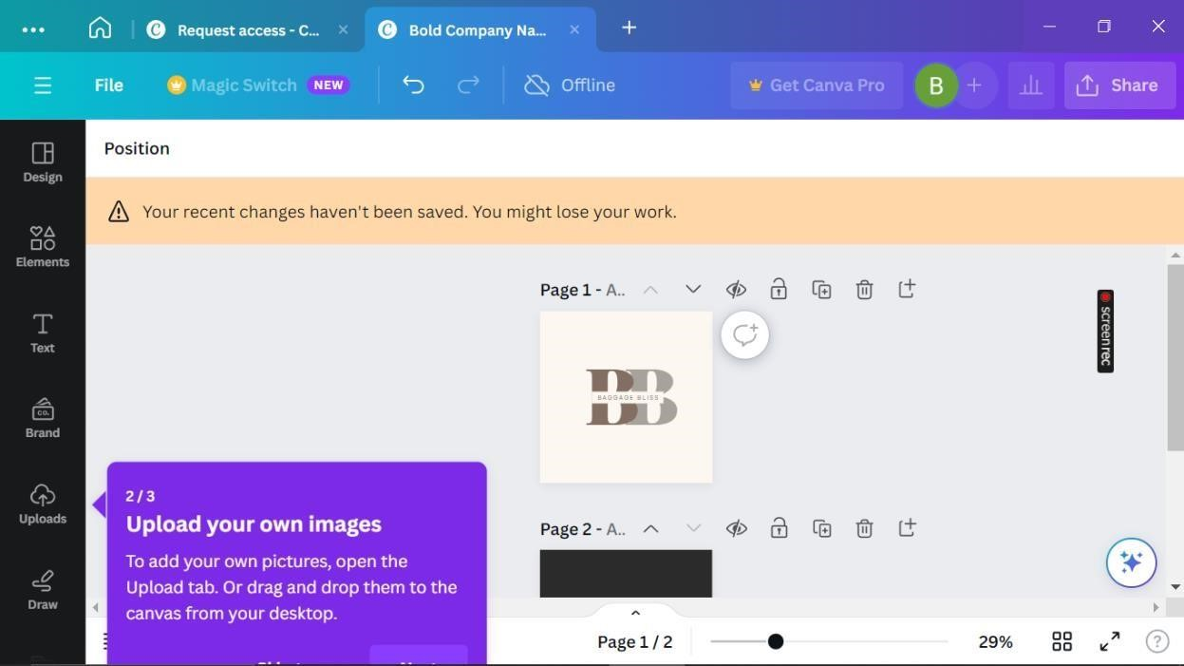

**STEP:7 Once you have customized your logo, click “Download”.**

